**Function Development – Gabrielle Marquez**

**Wireframe Storyboard**

­­­­­­­

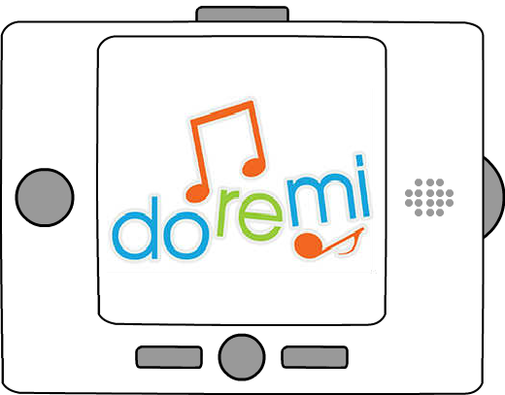

**Splash Screen**

The splash screen is displayed when users initially power up the device. It will feature the product’s logo for a few seconds before going to the home screen.

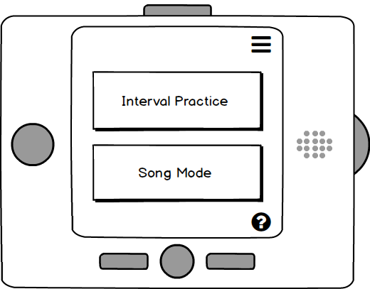

**Home**

The home screen immediately offers the device’s two mode options: interval practice and song mode. In the top right corner is a drop-down menu bar and in the bottom right corner is a help button. The options are navigated using the two rectangular push buttons, traveling across the screen in the order of Interval Practice, Song Mode, Menu, and Help. The current option will always be indicated by an orange outline around the image or text. The center bottom button is pressed to choose an option.

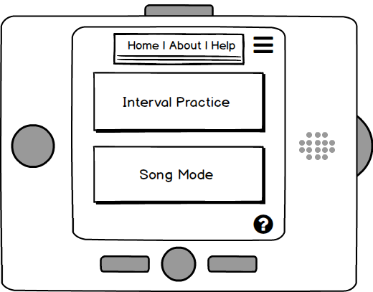

**Menu**

The menu screen opens a sub window with three options: Home, About, and Help. The home option will close the Menu bar, About will open the About page, and Help will open the Help page. Choices are navigated with the push buttons below the screen.

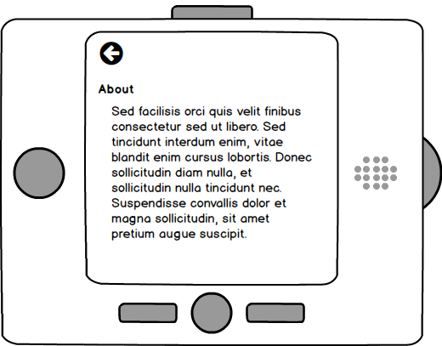

**About**

The about screen outlines the devices purpose and capabilities. It gives a concise explanation of harmonizing and how the device can be used to practice singing harmony. There is also a back arrow that when clicked goes back to the home screen.

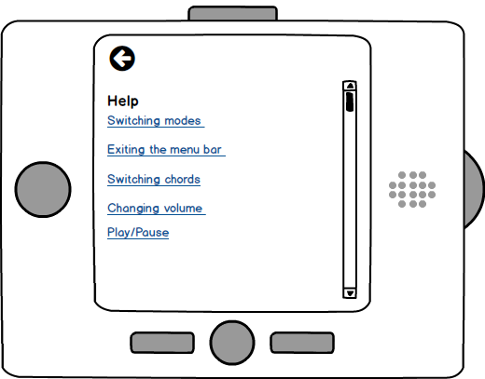­­­­­ ­­­­

**Help**

The help screen offers links to explanations of the devices major functions and possible areas of confusion. The scroll down feature on the right helps indicate that there are more options not currently being displayed on the screen. The right rectangular button moves the highlighted option down and the left button moves the highlighted option up.

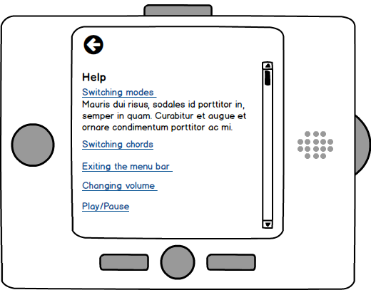

**Help Cont.**

When one of the links is chosen, an explanation is revealed below the subject line. Clicking on the link again will close the explanation.

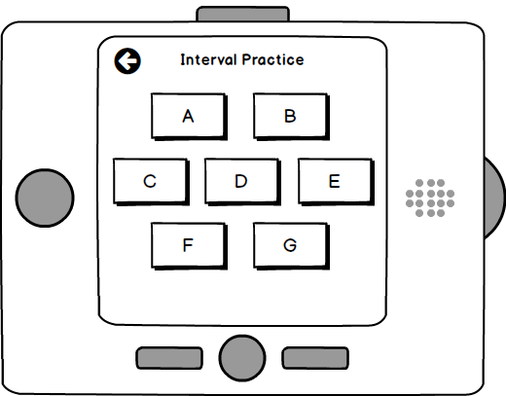

**Interval Practice**

The interval practice screen offers 7 different chords for users to practice harmonizing with. Using the two rectangular push buttons navigates through the options in the order of: A, B, C, D, E, F, G, back arrow, and then back to A again. The back arrow returns users to the home screen.

**Chord Display**

The chord display screen shows what chord the device is currently on (in this case, C). On the staff, the bass note (melody) and its 3rd above that (harmony) are shown. The vertical bars at the bottom indicate how in tune the person is with the harmony that they are supposed to be singing. Bars to the left indicate that they are flat, bars to the right that they are sharp, and the bar in the center indicates that they are in tune. The return arrow will return users to the interval practice page. If the circular button to the left is held down, the harmony will be heard over the melody. The center button can also be used to play/pause the melody being played when the chord name is highlighted.

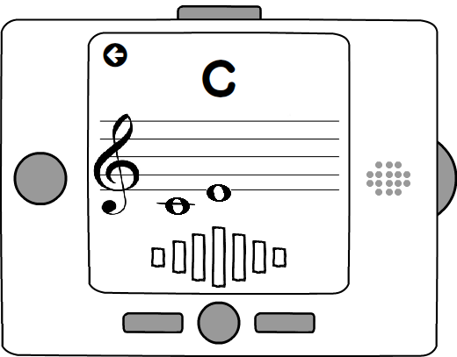

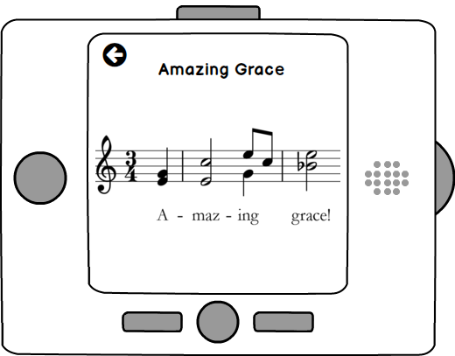

**Song Mode**

Song mode will play the melody for a well-known song and display the lyrics, the melody, and the harmony above that on the staff. The center button can be used to pause or play the song when the song title is highlighted. The return arrow will take users back to the home screen. The left push button will play the harmony so long as the button is being pressed.

**Component Sketch**

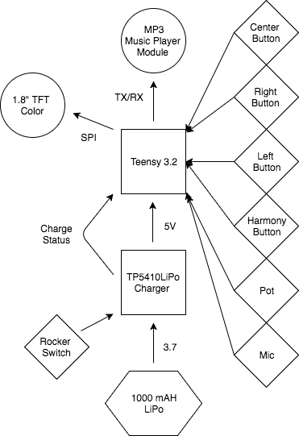

**Bill of Materials**



* + Breadboard Model - Create a breadboard model in **Fritzing** simulating your circuit. Components should be well spaced and wire jumpers should be discernible.
  + Electronic Schematic - Create an electronic schematic in **Fritzing** showing your circuit with appropriate connections made in a well organized manner.